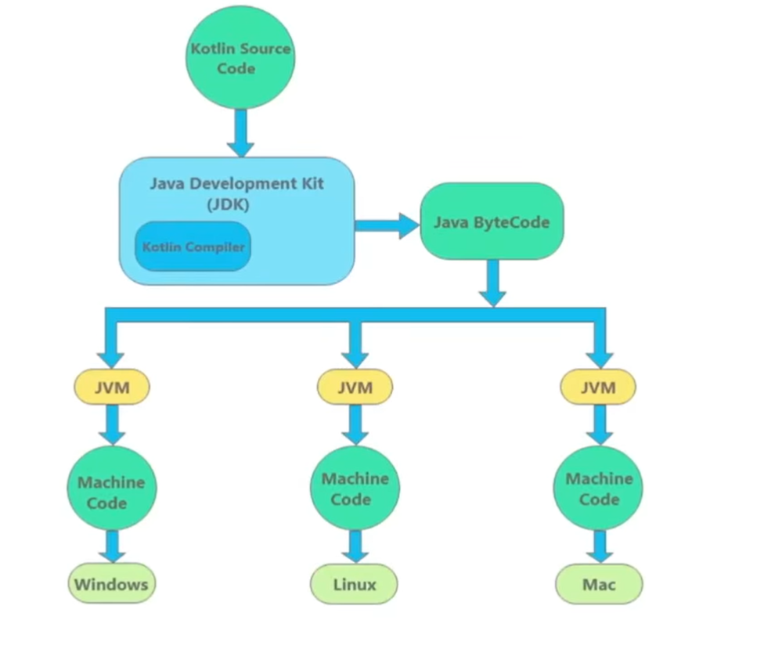

Final Code which is processed by CPU.

Different Platforms/OS

It converts it into computer understandable language I.e. binary code. It is basically a compiler.

Java Virtual Machine converts the bytecode to machine code which can be understood by a platform.

Instruction Set for JVM. Lies between high and low level language. Intermediate Code

Human understandable code which we write. Computer does not understand it.

So Java and Kotlin are totally Interrelated.